Experiment 1:

Pre lab:

a)

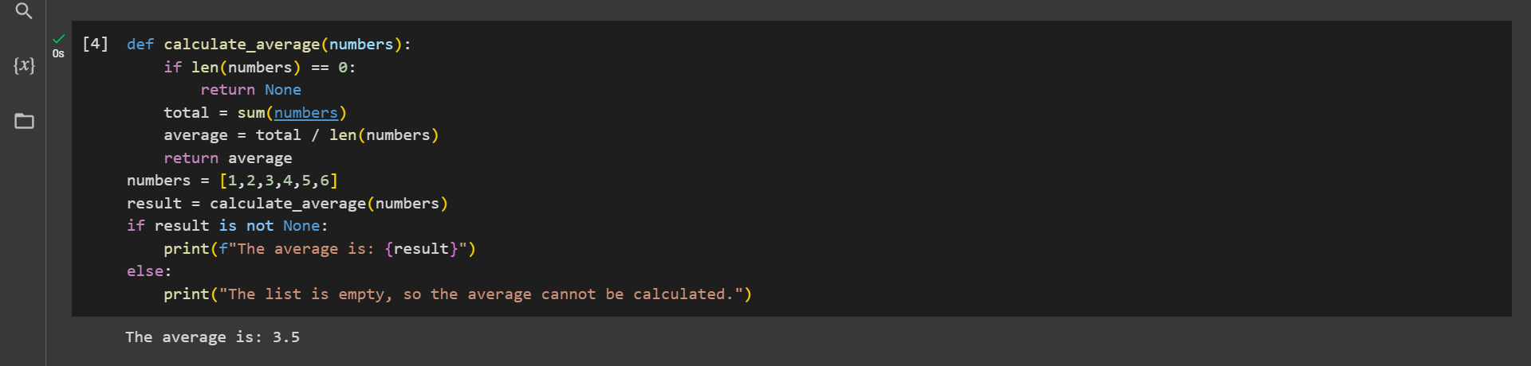

b)

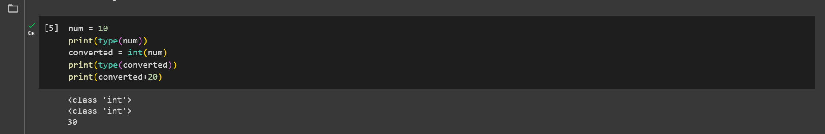

In-lab:

a)

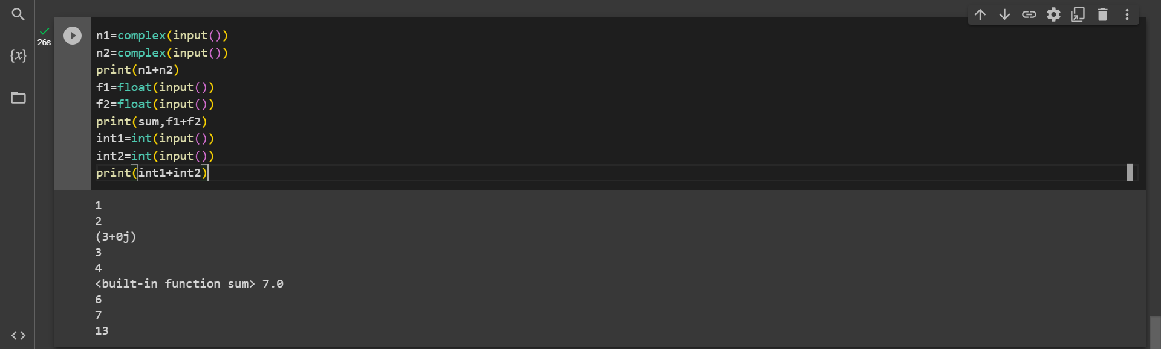

b)

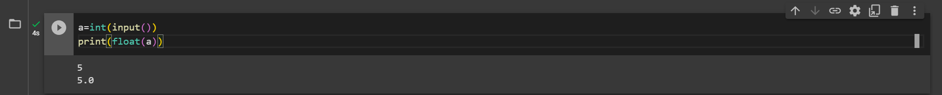

c)

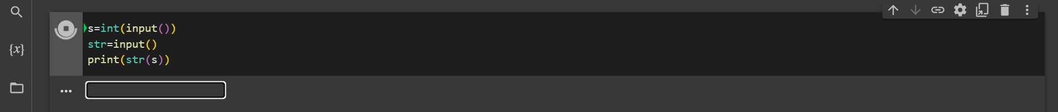

Post lab-

a)

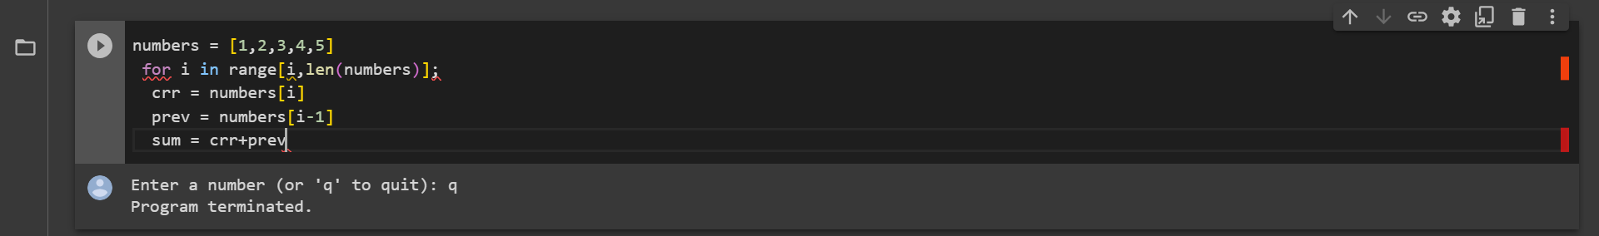

b)

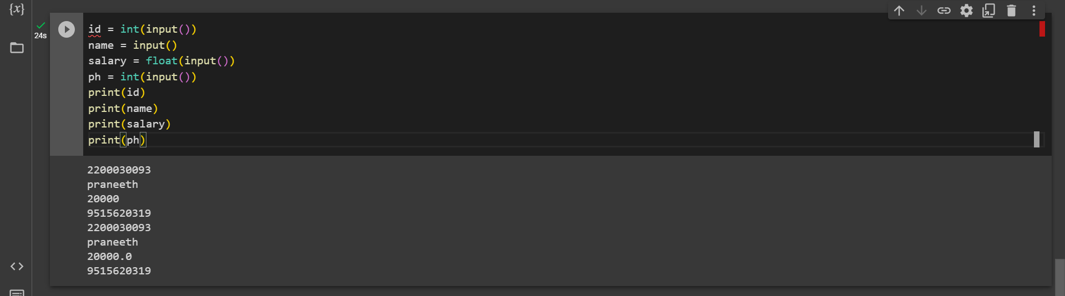

Experiment 2

Pre-lab

a)

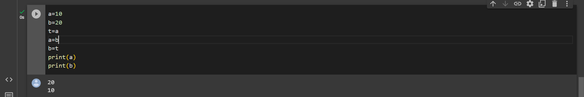

In-Lab

a)

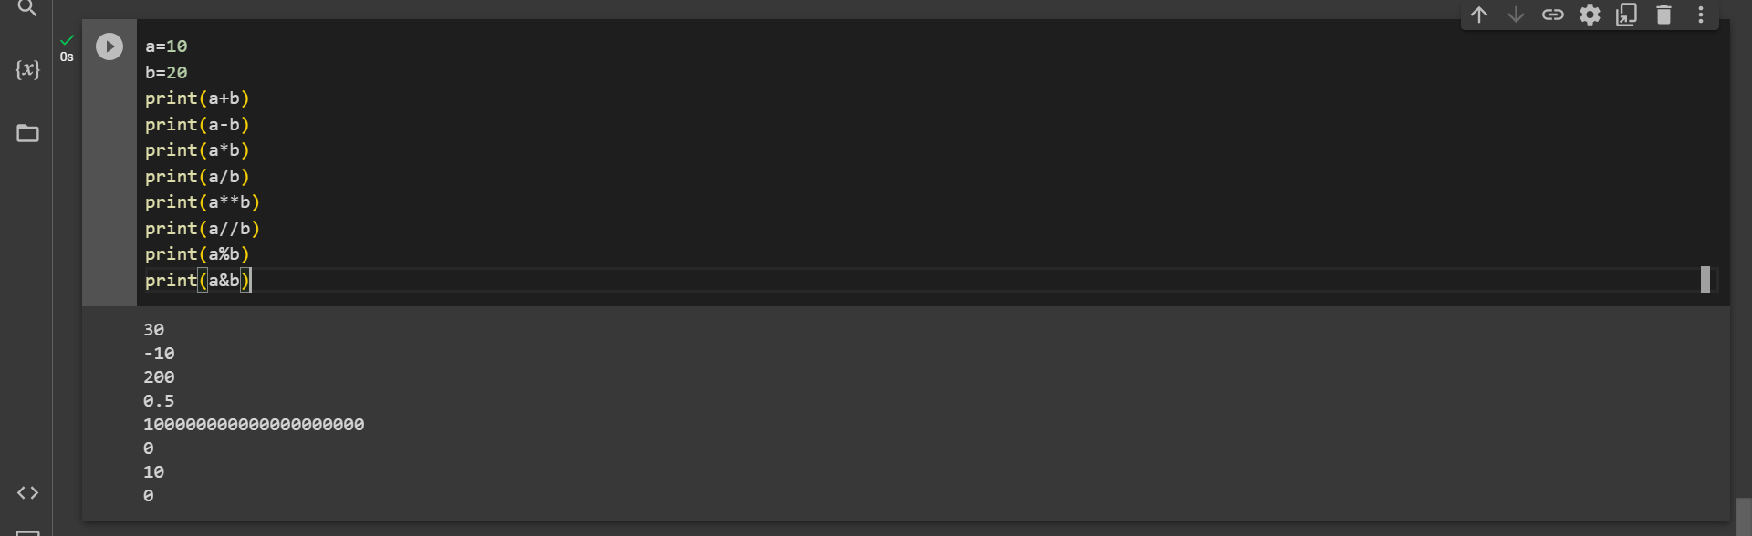

Post-lab

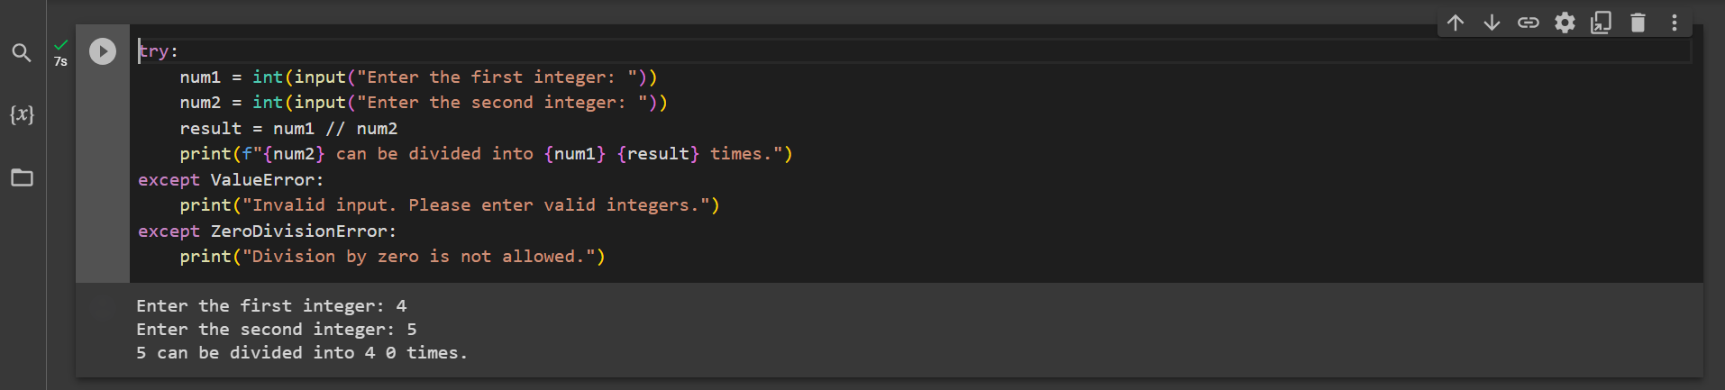

Experiment -3

Pre-lab

a) 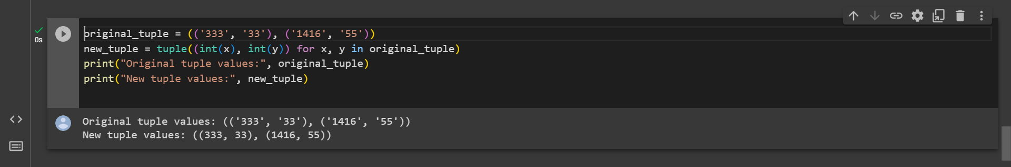

In-Lab

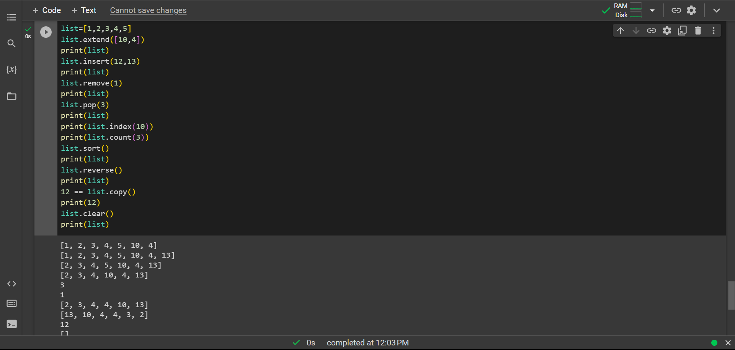

Post-lab:

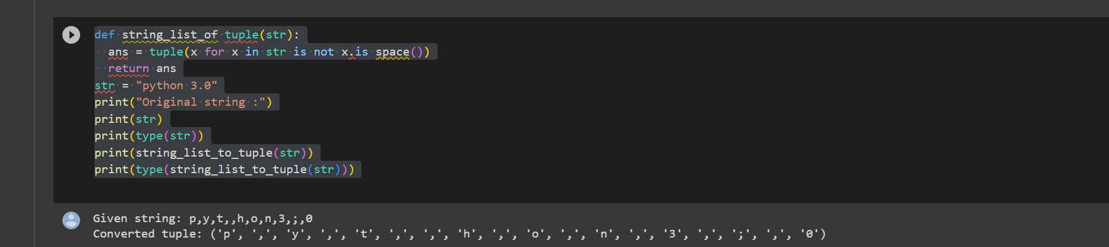

Experiment 4

In lab

a)

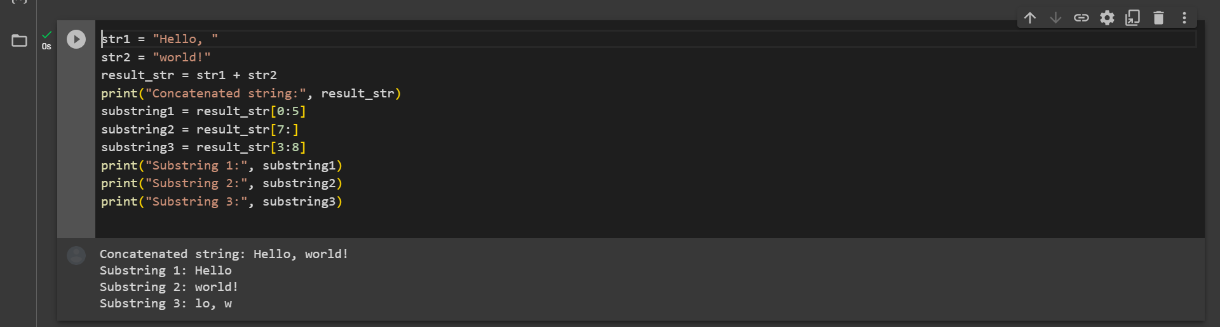

b)